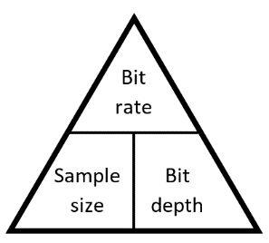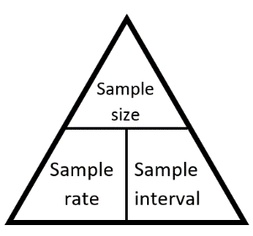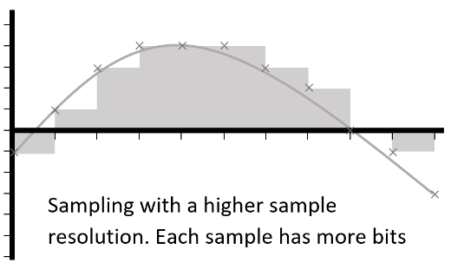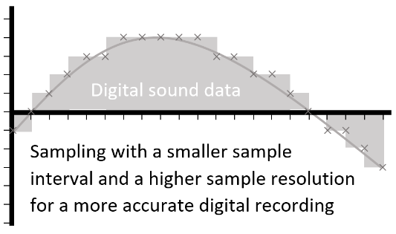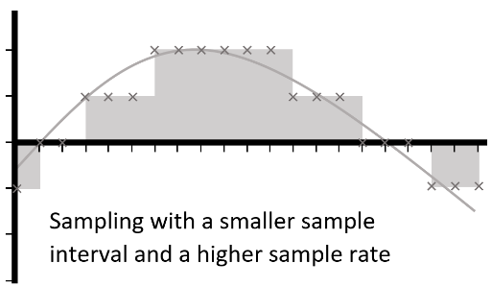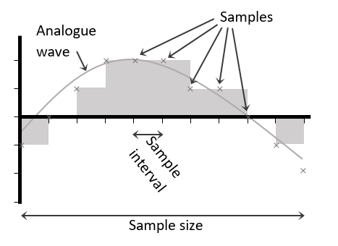

Sample rate

1

Name:

Data Representation: Compression of Sound

|  |  |  |  |
| --- | --- | --- | --- |
| **A** | **Representing Sound** | | |
| **Digital** | | Having discrete values which can be stored as binary | |
| **Analogue** | | Having continuously changing values | |
| **Sample** | | The smallest element of a recorded sound. A value or set of values which represent a sound at a specific moment | |
| **Sample size** | | The number of seconds over which a *sample* was taken | *s* |
| **Sample rate** | | The number of times per second the sound is sampled. *Sample size* ÷ *sample interval* | *Hz* |
| **Bit rate** | | The number of bits used to store a second of sampled sound. *Bit depth* × *sample rate* | *bps* |
| **Sample interval** | | The length of time between two samples | *s* |
| **Bit depth / Sample resolution** | | The number of bits used to store each sample | *b* |
| **Channel** | | An audio file which is intended to be played at the same time as another | |
| **File size** | | *Sample rate* × *bit depth* × *sample size* | |